IMAGES OF SAGO

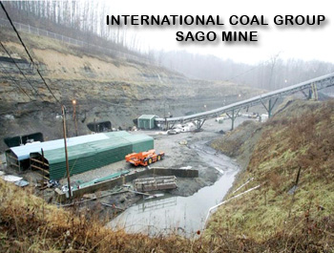

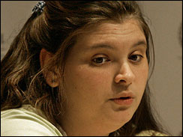

Anna McCloy, the wife of Randal McCloy Jr., speaks to reporters during a news conference on Friday, Jan. 6, 2006 at Allegheny General Hospital in Pittsburgh. (AP (file))

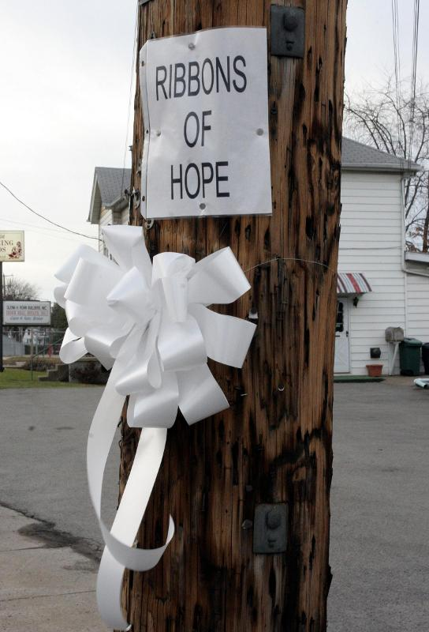

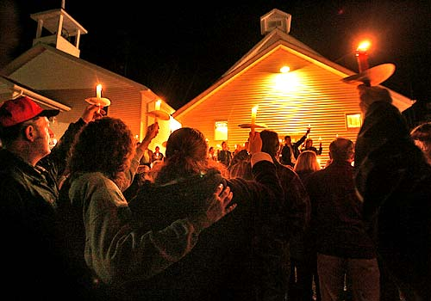

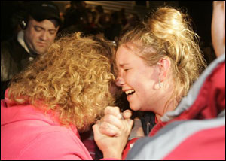

AP Photo/Kiichiro Sato
Shortlived Joy: Darline Graves, left, and Crystal Neeling hold each other to celebrate at Sago Baptist Church Tuesday, Jan. 3, 2006, in Tallmansville, W.Va. after hearing the miners are alive. Hours later, those reports were found to be untrue.

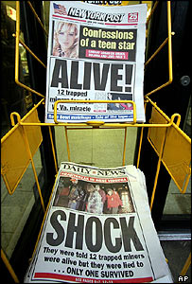
The reversal left relatives who had gathered at the mine here stunned and furious
New York Times
US media exposed

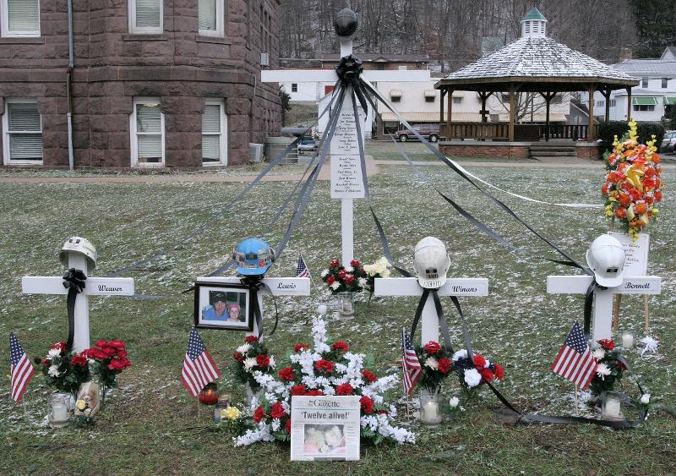
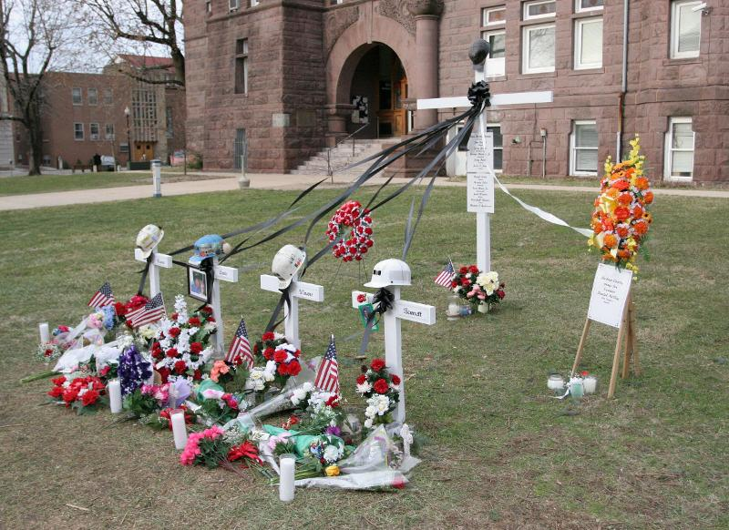

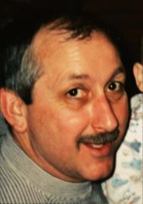

(enlarge photo)
51-year-old mine foreman Martin Toler Jr. wrote one of at least four notes.

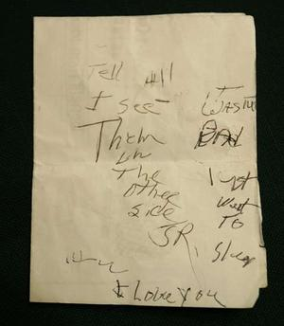

"Tell all I'll see them on the other side," read the note found with the body of 51-year-old mine foreman Martin Toler Jr. "It wasn't bad. I just went to sleep. I love you Jr."
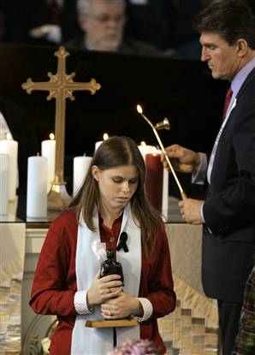 Scene 8
Keith Srakocic / Pool via AP
West Virginia Gov. Joseph Manchin helps Amber Helms light a candle in memory of her father, Terry Helms, at the Wesley Chapel on Sunday in Buckhannon, W. Va.

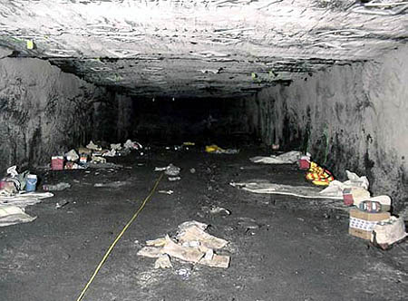

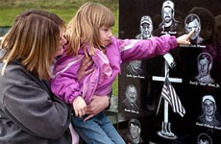
Jeff Gentner, Associated Press
Holly Winans, the daughter of miner Marshall Winans, who died at the Sago mine a year ago, holds up family friend Ashley Fortney, 5, to point to an engraving of Mr. Winans at the miners' memorial yesterday in Tallmansville, W.Va.
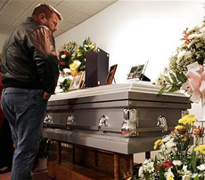
An unidentified family member stands at the coffin of Jerry Lee Groves

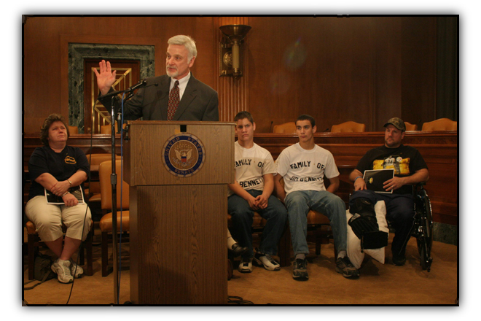
UMWA President Cecil E. Roberts makes a point during the press conference
while the family of Sago miner Jim Bennett looks on.

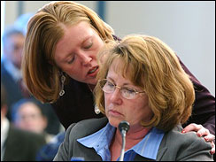
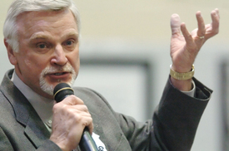
United Mine Workers President Cecil Roberts makes his closing statement during the final day of the Sago Mine disaster hearings. AP photo by Dale Sparks
Deborah Hamner with daughter, Sarah on Capitol Hill Monday, Feb. 13, 2006, during a Congressional forum on mine safety. (AP)
Quote
"It breaks my heart to know there is modern technology that could have prevented my husband's death, and the Sago mine wasn't equipped with it." Debbie Hamner

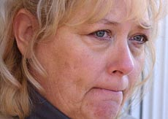
Pam Campbell, sister-in-law of Martin Bennett: "It's the same answers that we've been getting all along. A lot of the questions are questions that the families have been asking from the beginning, and we still have no answers.”
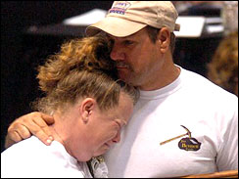Ann Merideth, daughter of miner James Bennett, cries while listening to a tribute song during the first day of the Sago Mine hearings, May 2, 2006. (AP)

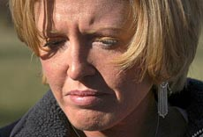
Steve Mellon, Post-Gazette photos
Sara Bailey, daughter of George "Junior" Hamner: "I don't believe the explanation. Basically, all they have is a hypothesis. They are not telling us anything new."

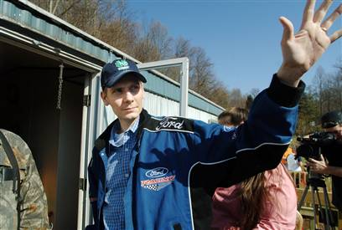
Jeff Gentner / AP

Sago Mine survivor Randal McCloy Jr. returned home to Simpson, W. Va.

Wilbur Ross, Owner, ICG

©Bryce Duffy / Corbis Outline

Ben Hatfield, ICG CEO

